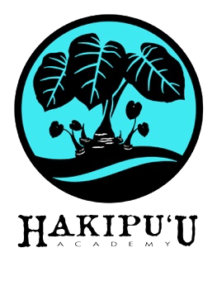
HAKIPU‘U ACADEMY
A Public Charter School
Ma ka hana ka ‘ike Learning is in the doing

January 25, 2021

Aloha Hakipu`u Ohana,

Happy New Year!!! I hope you and your extended ‘ohana are healthy and keeping safe during these uncertain times.

Mahalo for always being supportive of our Kumu and Staff for everything they do to help support your keiki develop into strong young men and women. We are concerned that the COVID numbers have increased over the break but are hopeful that our community will become safer as the vaccine becomes available to all.

For this quarter, we have changed the Thursday schedule to begin one-on-one/small group meetings with our keiki that are struggling with distance learning. In the next few weeks, we will be asking all students to come to campus and participate in Mo‘omona activities. We will be following all CDC guidelines to keep everyone safe. Please look for updates from kumu as we invite more keiki to engage in our new protocols.

Enclosed is your childʻs 1st semester report card and information about the WCC TriO program. TriO provides career and college planning activities to Hakipu‘u students. Please scan the QR code on the flyer with your phone camera and complete the TriO application or apply online, search WCC TriO ETS application then select “Apply for TRiO ETS | Windward Community College” to complete the application.

If you have any questions or concerns, donʻt hesitate to call the office.

Me ka mahalo nui,

Michael Nakasato
Po‘o
Hakipu‘u Academy

